|  |
| --- |
| **LAB 4** |
| SOAP AND RESTFUL SERVICES |
|  |
| This assignment deals with the creation of SOAP and RESTFUL Services along with the mobile web client application and making access through cloud instance. |
|  |
| **Karthik Repala** |
| **9/23/2013** |
|  |

**MOBILE WEB CLIENT**

In order to create a mobile web client application,

Go to Menu--Add New Item(By right clicking project)--Select Web Form from the list.

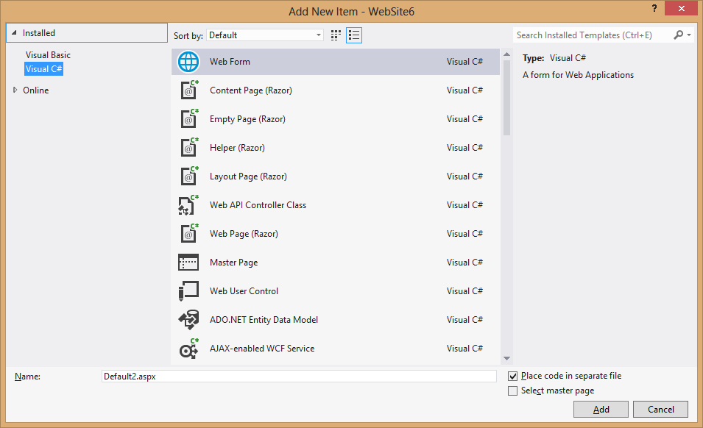

Add reference to the Webform by right clicking and selecting the Add to Reference

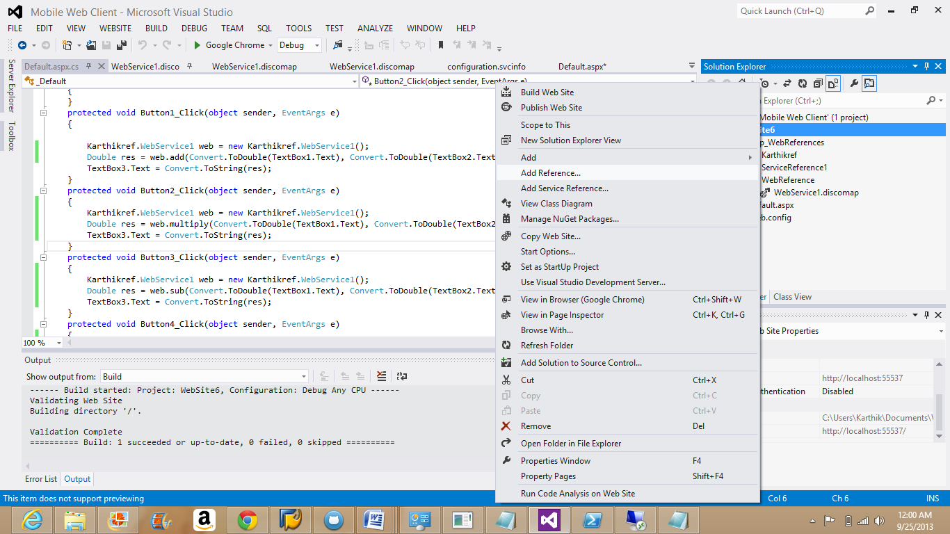

Design the web page by using drag and drop option in the Tool Box option.

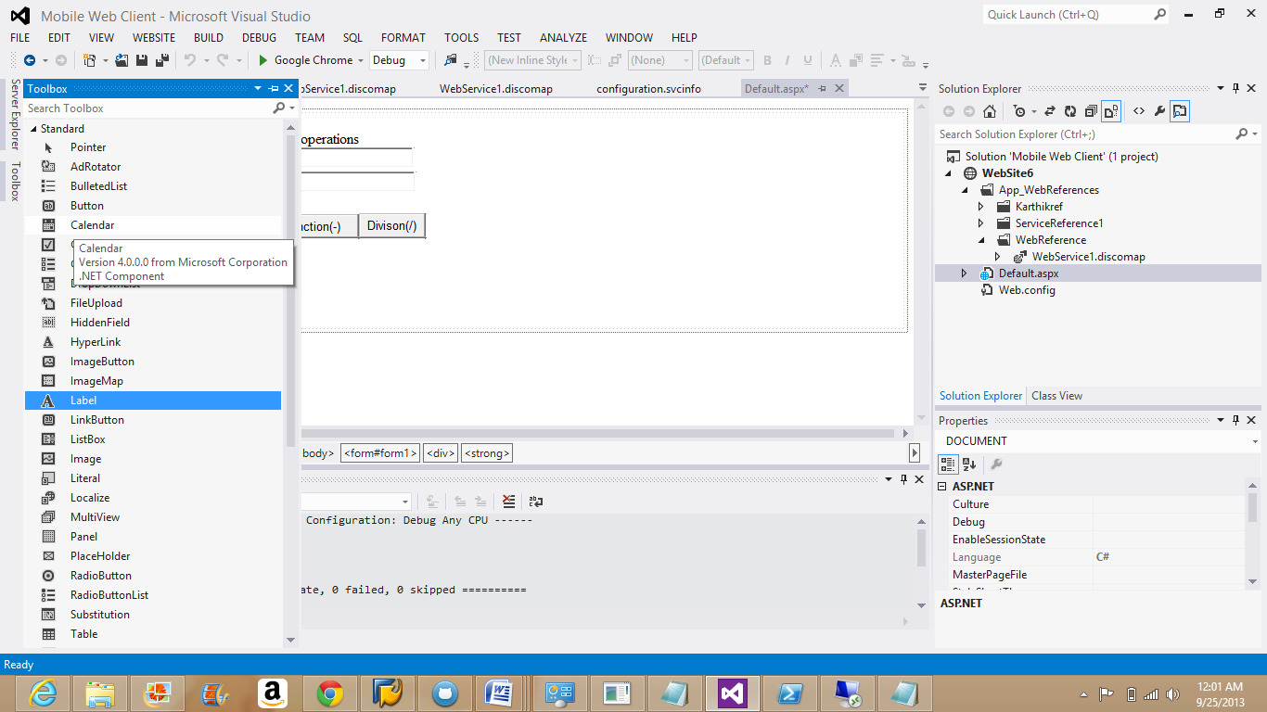

Desgin the webform

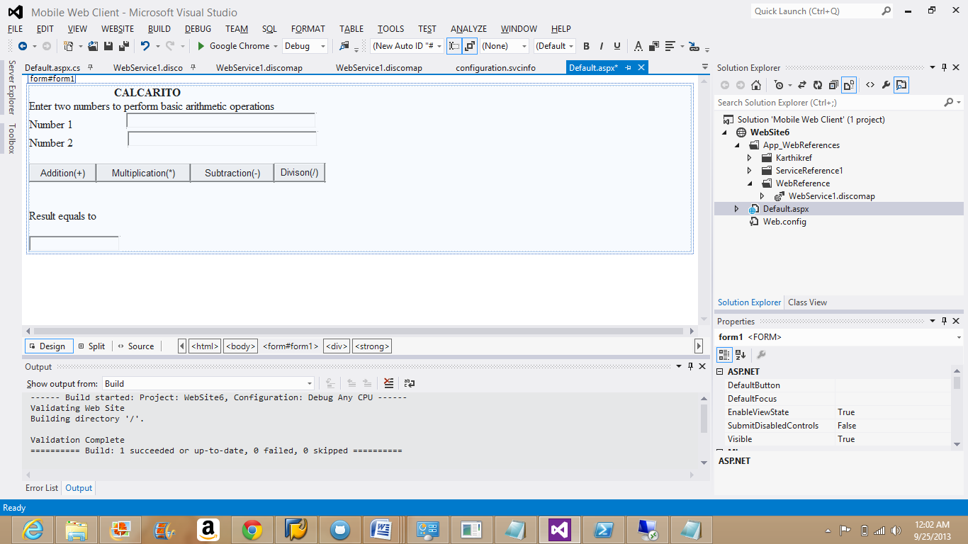

The Mobile Web application created is named **Calcarito**

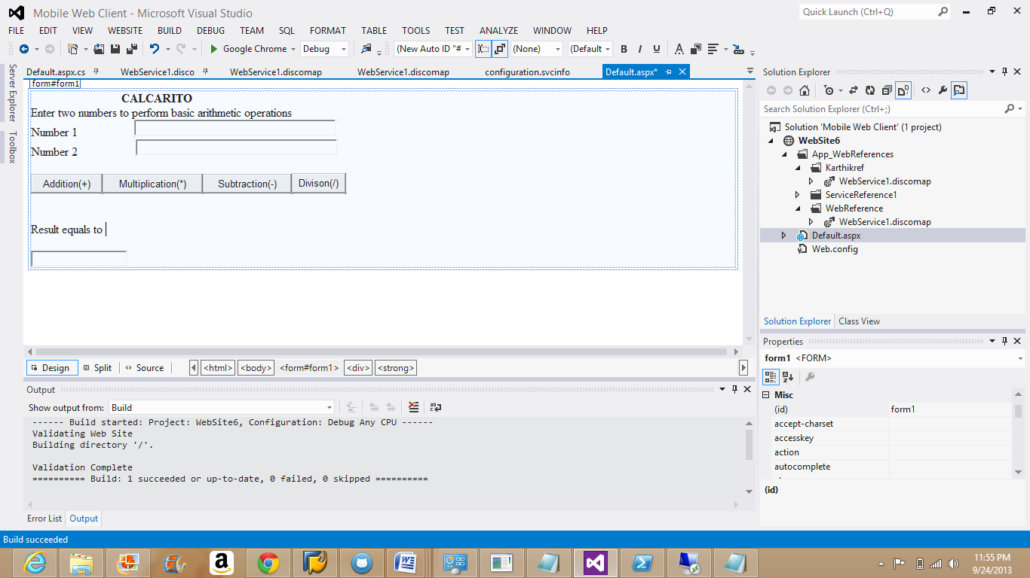

Make changes to the text boxes and labels by changing the code in source fields

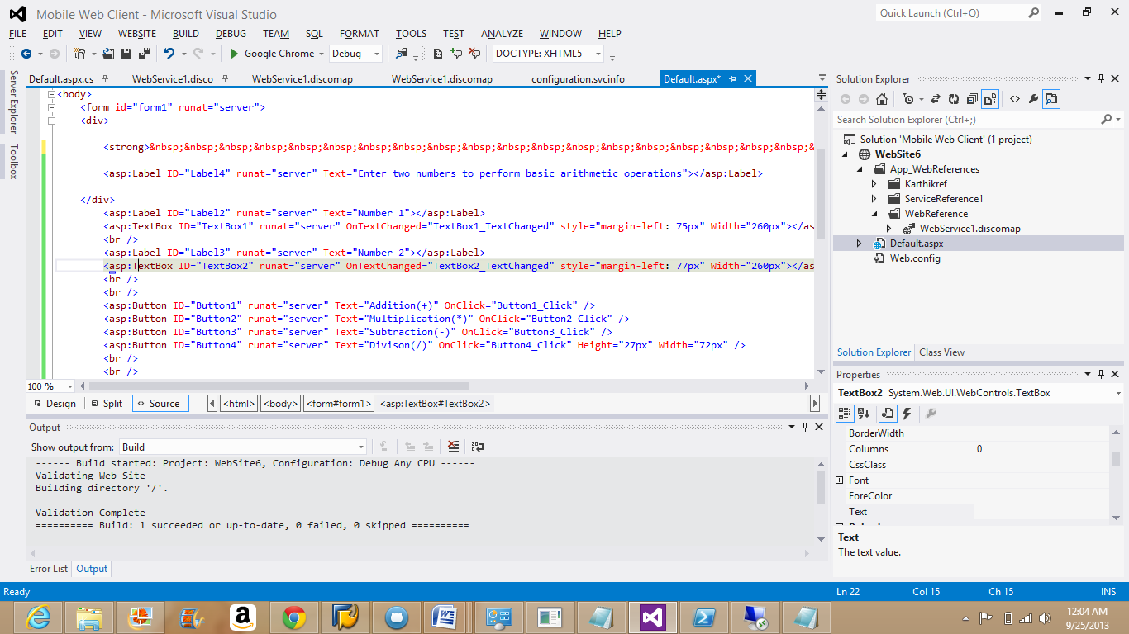

Build the Solution and debug without errors.

The below screen shot is from local system

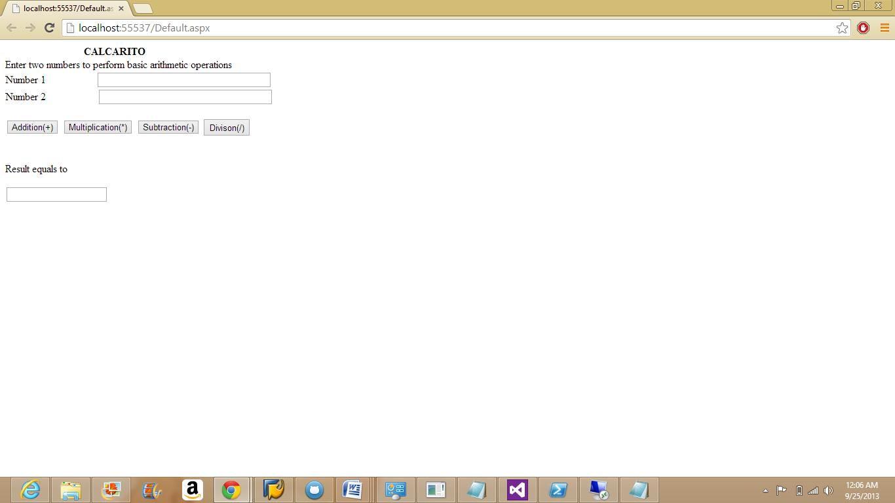

**Addition:**

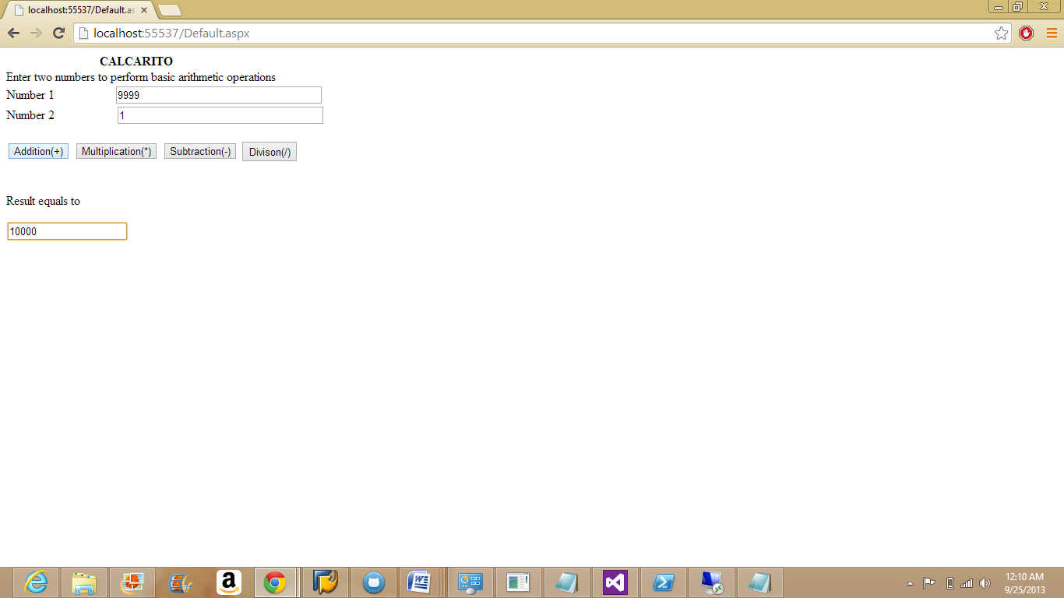

**Subtraction:**

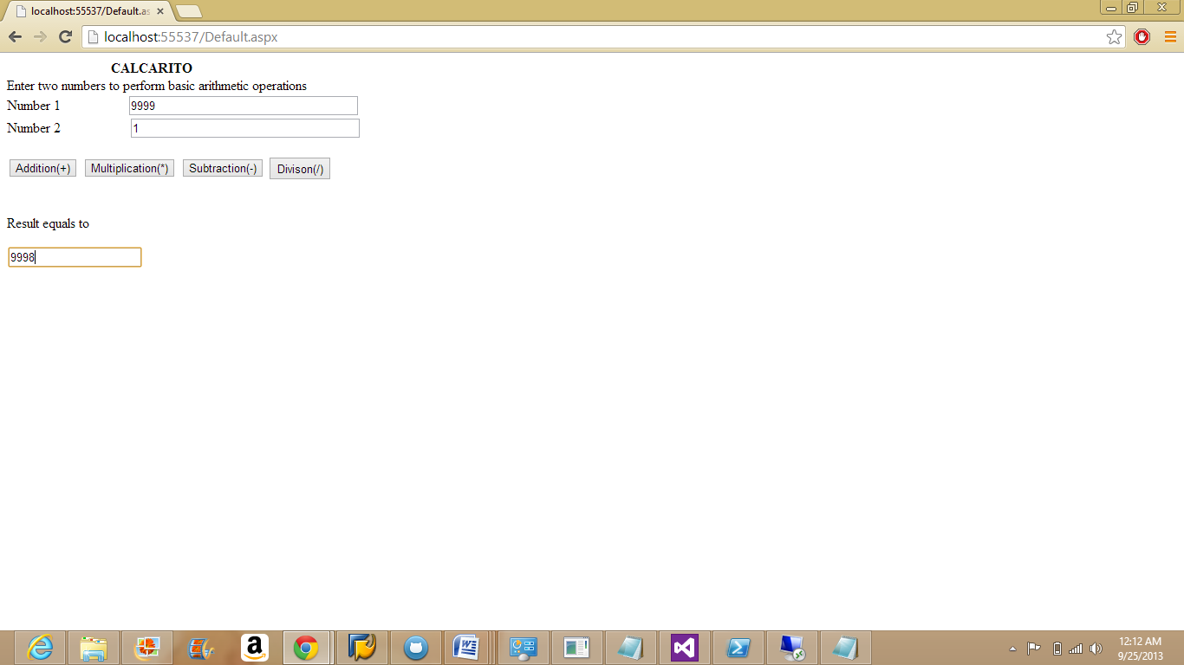

**Multiplication:**

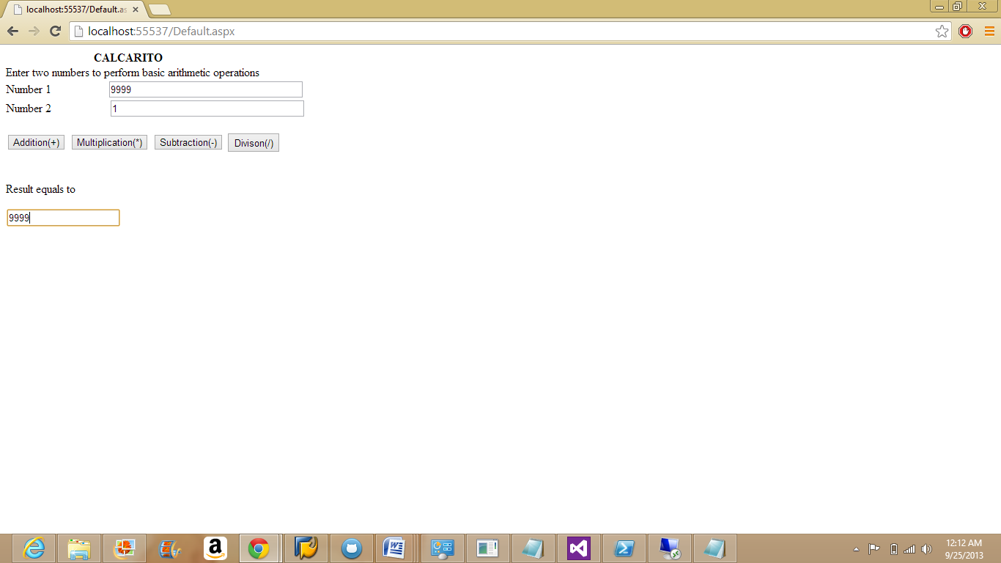

**Division:**

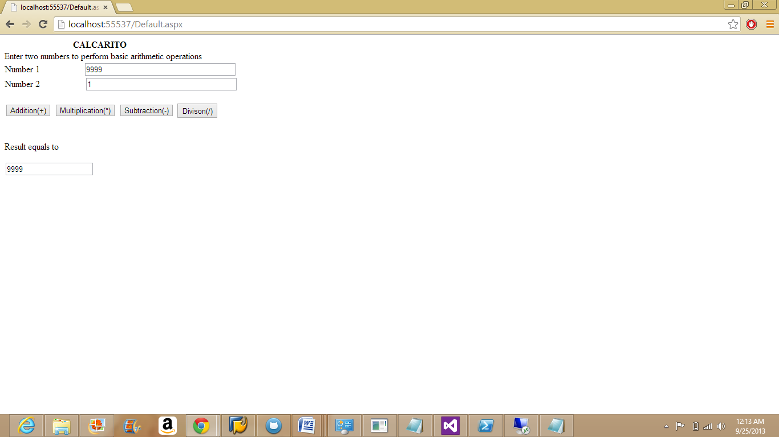

Deploy the source website into to the cloud instance:

Copy the source code and paste in to the path-

**C:\inetpub\wwwroot\aspnet_client**

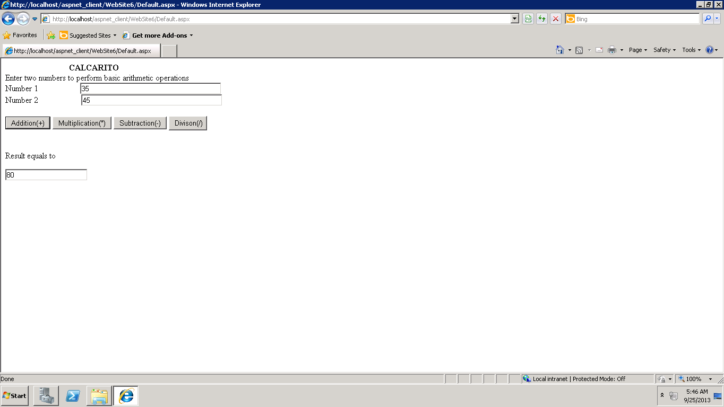The addition for numbers can be cross checked in the cloud instance.\

The IP address of the cloud instance is 170.224.168.204.

Now replace the "localhost" with the IP address and access from local system.

